Minimal Subscenes: Linking Language and Action
A Plan for Further Research
Michael A. Arbib and Laurent Itti
October 1, 2001

Abstract
Studies of the interaction between focal visual attention and the recognition of objects and actions will lead to a better understanding of how humans perceive and act upon complex dynamic scenes and how such perception and action are linked to language. The work will focus on the study of "minimal subscenes" in which an object is linked to another object or two via some action, and on the basic sentences containing a verb together with noun phrases which express such a subscene.
Modeling will develop, extend and integrate computational components for neural action recognition, neural bottom-up visual attention, activity recognition and minimal subscene representation. The result will be an integrated model of dynamic scene understanding, scene description and question answering.
Visual psychophysics experiments will test human performance on minimal subscene description and recognition, question answering, and related attentional processes. The results will guide design of functional magnetic resonance imaging experiments to obtain data which will constrain our analysis of how the interactions among our model components should be developed so as to best match patterns of neural specialization.. This will yield a conceptual framework for the study of aphasia and apraxia.

Specific aims
In clinical studies, there are both overlaps and differences in the effects of brain lesions on language and action, i.e., on aphasia and apraxia. We propose a basic scientific study of the relation between action and language which uses computational analysis to integrate our insights based on data by other researchers of neural circuitry of the monkey brain with data on the human brain gathered by ourselves and others.
The empirical grounding for this dual linkage - of monkey and human, and of action and language - comes from studies of the role of premotor cortex in monkey during grasping. There, it is found that that a subset of grasp-related cells, the mirror neurons for grasping, are active not only when the monkey generates a specific action, but also when the monkey observes a human or other monkey performing a related action. This led to a search for "mirror systems" in the human brain, i.e., regions shown to be active both for grasping an object and for observing the grasping of an object, but not for simple observation of the object. Significantly, the premotor mirror region in the human brain was found by PET studies to lie in Broca's area, a key component of the human language system. The Mirror System Hypothesis states that this capacity to generate and recognize a set of actions provides the basis for language parity, in which an utterance means roughly the same for both speaker and hearer. This hypothesis suggests that we can develop a new analysis of the linkage between aphasia and apraxia by conducting experiments in human psychophysics to analyze behaviors linking action, action recognition and language, and new fMRI brain imaging studies to suggest and test hypotheses concerning the localization of key schemas constituting the variety of behaviors studied in greater parametric detail using psychophysics. To codify and explain the findings of these and related studies, we will extend our existing models of both the mirror system in monkey and of mechanisms of visual attention to chart the human brain mechanisms for recognizing, describing, and answering questions about interactions of actors and objects, and use this to ground a theory of brain representations underlying human capacities for symbolizing actions, objects and actors.
We propose to explore the interaction between focal visual attention and the recognition of objects and actions to better understand how humans perceive and act upon complex dynamic scenes and how such perception and action are linked to language. To focus the work, we shall concentrate on the study of "minimal subscenes" in which an object is linked to another object or two via some action, and on the basic sentences containing a verb together with noun phrases which express such a subscene. Extending our earlier work on visual attention, we shall ask
- Given a video, what draws the viewer's attention to a specific object or action, and then expands that attention to determine the minimal subscene containing that focus of attention?
- Given a minimal subscene, what sentences does the viewer generate to describe it, and to what extent does the initial focus of attention bias the type of sentence structure used for the description?
- Given a question about a visual scene, how does this provide a top-down influence on mechanisms of attention as the viewer examines the scene in preparation to answer the question?
Modeling: We will extend and integrate the computational components which we have developed for neural action recognition, neural bottom-up visual attention, and a computer vision system for activity recognition model. We will devise new components for minimal subscene representation, which, when brought together with the new, neurally consistent extensions of our existing components will yield the first complete model for dynamic scene understanding integrated with scene description and question answering. From this modeling we will extract a conceptual analysis of Aphasia and Apraxia.
Experiments. We will conduct visual psychophysics experiments at the University of Southern California (USC) to test human performance on minimal subscene description and recognition, question answering, and related attentional processes. The results will enable us to design functional magnetic resonance imaging which we will conduct at Brookhaven National Laboratory (BNL). Data from the experiments constrain our analysis of how the interactions among our model components should be developed.

Background and significance

Significance
We propose a basic scientific study of the relation between action and language which uses computational analysis to integrate insights based on data on neural circuitry of the monkey brain with data on human brain and behavior into a set of detailed models of the role of interactions between multiple brain regions. Our modeling will be complemented by data collection using new experiments in both human psychophysics and fMRI to probe the relation between action recognition, scene description and question answering. The work will complement studies of object-based attention by providing new insights into action-based attention, and help us understand how the modulatory effect of attention differs with the nature of the task being performed, as in scene description versus question answering, where in each case we can design experiments which differentially employ a number of processes. We intend to use these models to help define a new framework for clinical studies on aphasia and apraxia. Thus, in addition to our modeling and experiments, we will provide expositions of our findings in a form accessible to neurologists concerned with the overlaps and differences in the effects of brain lesions on language and action. Finally, this research will make an important methodological contribution by showing how a combination of detailed modeling of neural systems based on data from monkey brain, human psychophysics, and fMRI can provide a useful new approach towards a greater understanding of complex aspects of human brain function.

Background
In the next few pages, we will provide an initial review of background material on the Mirror System Hypothesis, visual attention in primates, scene understanding, activity recognition, and functional neuro-imaging. In the following section, we extend the background on three of these areas by reporting on our preliminary studies modeling the mirror system, mechanisms of attention, and activity recognition.

The Mirror System Hypothesis
Rizzolatti et al. (1988) found neurons coding for grasp commands in area F5 of premotor cortex, while the Sakata group (Taira et al., 1990) found neurons coding for grasp affordances (sensory data useful for interacting with the world) in area AIP of parietal cortex. Moreover, Rizzolatti et al. (1996) found a subset of F5 neurons which discharge not only when the monkey executes certain hand movements but also when it observes similar movements made by others. Thus monkey F5 contains an "observation/execution matching system" which we call the mirror system for grasping. Figure 1 provides an anatomical overview.
Figure 1. cIPS (caudal intraparietal sulcus) extracts axis orientation and surface orientation to provide input for the computation both of affordances by the anterior intraparietal area AIP and of object identity. F5 contains premotor neurons whose activity is related to specific grasps; a subset of these (mirror neurons) are also active when the monkey observes a grasp similar to that for which they are active during execution. PF (rostral part of the posterior parietal lobule) and PG (caudal part of the posterior parietal lobule) provide key parietal input for mirror neurons, analyzing motion during interaction of objects and self-motion. STS (Superior Temporal Sulcus) has many subregions, including those involved in detection of biologically meaningful stimuli (e.g., hand actions) and motion related activity (in areas MT and MST).
The notion that a mirror system might exist in humans was tested by two PET experiments (Rizzolatti et al., 1996a; Grafton, Arbib, et al., 1996b). The two experiments differed in many aspects, but both compared brain activation when subjects observed the experimenter grasping a 3-D object against activation when subjects simply observed the object. Grasp observation significantly activated the superior temporal sulcus (STS), the inferior parietal lobule, and the inferior frontal gyrus (area 45). All activations were in the left hemisphere. The last area is of especial interest – areas 44 and 45 in left hemisphere of the human constitute Broca's area, a major component of the human brain's language mechanisms. Moreover, F5 in monkey is generally considered (Rizzolatti and Arbib 1998) to be the homologue of Broca's area in humans. More recently, an fMRI study by Buccino et al. (2001) demonstrated a somatotopic activity pattern extending from ventral to more dorsal regions in premotor cortex during the observation of mouth, arm/hand, and foot actions respectively.
Taken together, human and monkey data indicate that in primates there is a fundamental mechanism for action recognition that in humans extends from hand movements to language. Rizzolatti and Arbib (1998) built on these observations. They added to the tradition (see Stokoe 2001 for a recent overview) rooting speech in a prior system for communication based on manual gesture the new hypothesis that the mirror system provides a neural “missing link” in the evolution of human language-readiness:
The Mirror-System Hypothesis states that Broca's area in humans evolved from the mirror system for grasping in the common ancestor of monkey and human. The mirror system's capacity to generate and recognize a set of actions provides the evolutionary basis for language parity, in which an utterance means roughly the same for both speaker and hearer.
Studies of the visual system of the monkey led Ungerleider and Mishkin (1982) to distinguish inferotemporal mechanisms for object recognition (“What”) from parietal mechanisms for localizing objects (“Where”). Goodale et al. (1991) extended this to humans, providing data relating action to communication. They studied a patient with damage to the inferotemporal pathway, who could grasp objects appropriately but could not report their size or orientation. They thus viewed location as just one parameter relevant to how one interacts with an object, renaming the “Where” pathway as the “How” pathway. Another patient with damage to the parietal pathway could communicate the size of a cylinder but not preshape appropriately, but could preshape appropriately if the “semantics” of an object indicated its size.
Thus, where the Mirror System Hypothesis emphasizes the common roots of mechanisms for action generation and recognition with mechanisms for language parity, the Goodale et al. data provide complementary evidence for differentiation of pathways involved in thee use of motor parameters concerning an object and their verbal expression. Together with a large body of related studies, they ground our proposed analysis of the linkage of mechanisms for language and action.

Visual Attention in Primates
A large body of psychophysical evidence on attention can be summarized by postulating two forms of visual attention (Pashler, 1998). One is driven by the input image itself. This saliency-form of attention is rapid, operates in parallel throughout the entire visual field, and helps mediate popout (our tendency to automatically shift attention towards highly conspicuous objects). The second type of attention depends on the exact task and on the subject's visual experience, takes longer to deploy and is volitionally controlled using top-down feedback. Normal vision employs both processes simultaneously. Additionally, attention modulates neuronal activity along the object recognition pathway. Such modulation is expressed by enhancing the activity of neurons encoding for salient objects, sharpening competition between neurons encoding for nearby or overlapping stimuli (Lee et al., 1999), and also carrying attribute-specific information mediated by top-down processes from working-memory (Desimone & Duncan, 1995).(One part of our research will probe extensions to the action recognition pathway.)
Most models of visual search, whether involving overt eye movements or covert shifts of attention, are based on a saliency-map (Arbib and Didday, 1975; Koch and Ullman, 1985: Figure 2), an explicit, viewer-centered map that encodes the saliency of objects in the visual environment. Competition among neurons in this map gives rise to a winning location that corresponds to the next target “attended” by the system. Inhibiting this location automatically allows the system to attend to the next most salient location.
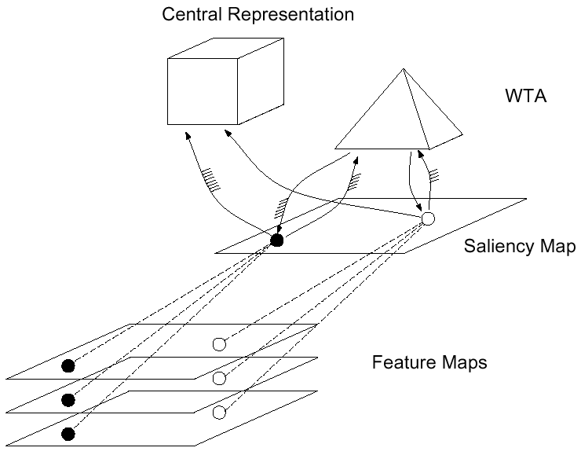
Figure 2. A model of saliency-based visual attention (Arbib and Didday, 1975; Koch and Ullman, 1985). Early visual features such as color, intensity or orientation are computed, in a massively parallel manner, in a set of pre-attentive feature maps based on retinal input (not shown). Activity from all feature maps is combined at each location, giving rise to activity in the topographic saliency map. The winner-take-all (WTA) network detects the most salient location and directs attention towards it, such that only features from this location reach a more central representation for further analysis.
While models of bottom-up attention may accurately describe how attention is deployed within the first few hundred milliseconds following the presentation of a new scene, a more complete model of attentional control must include top-down, volitional biasing influences as well. The computational challenge, then, lies in the integration of bottom-up and top-down cues to provide coherent control signals for the focus of attention, and in the interplay between attentional orienting and scene recognition. In most biological models of attention and visual search, such as the “Guided Search” model (Wolfe, 1994), top-down commands have been restricted to two very simple effects: feature-based biasing (e.g., increase gain of red/green color channel when looking for a red object) and spatial biasing (e.g., increase gain of all features at a given location), as supported by monkey physiology (Treue & Martinez-Trujillo, 1999). However, several computer models have directly attacked the problem of top-down influences. The model of Ryback et al. (1998; Figure 3a) stores and recognizes scenes using scanpaths (containing motor control directives stored in a “where” memory and locally expected bottom-up features stored in a “what” memory) that are learned for each scene or object to be recognized. When presented with a new image, the model starts by selecting candidate scanpaths based on matching bottom-up features in the image to those stored in the “what” memory. For each candidate scanpath, the model deploys attention according to the directives in the “where” memory, and compares the local contents of the “what” memory at each fixation to the local image features. This model has demonstrated strong ability to recognize complex grayscale scenes and faces, in a translation, rotation and scale independent manner. The model of Schill et al (2001; Figure 3b) operates similarly except that it employs an optimal strategy for deciding where to next shift attention (based on maximizing information gain). For a recent review see Itti & Koch, 2001nrn. While such computer vision models demonstrate limited computer vision performance, they lack biological correlates.
a. b.
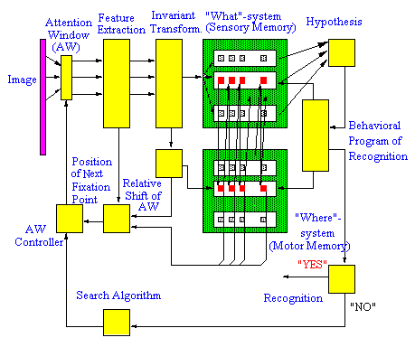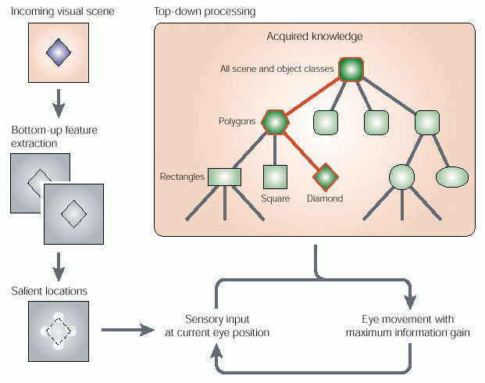
Figure 3: Two models of combined attentional deployment and localized feature analysis (recognition). (a) The model of Ryback et al. (1998). (b) The model of Schill et al (2001).
Of particular interest here is the extreme view expressed by the “scanpath theory” of Stark (Noton & Stark, 1971; Stark & Choi, 1996), in which the control of eye movements is almost exclusively under top-down control. The theory proposes that what we see is only remotely related to the patterns of activation in our retinas, as suggested by our permanent illusion of vivid perception over the entire field of view, although only the central 2° of our foveal vision provide such crisp sampling of the visual world. Rather, the scanpath theory argues that a cognitive model of what we expect to see is the basis for our percept; the sequence of eye movements that we make to analyze a scene, then, is mostly controlled by our cognitive model of that scene. This theory has had a number of successful applications to robotics control, in which an internal model of a robot's working environment was used to restrict the analysis of incoming video sequences to a small number of circumscribed regions important for a given task (Stark et al., 2001).
One important challenge for combined models of attention and recognition consists of finding suitable neuronal correlates for their various components. Despite a biological inspiration in their architectures, the models reviewed here do not relate in much detail to biological correlates of object recognition. Indeed, the original model of saliency-based visual attention (Arbib and Didday, 1975) provided a critique of the original scanpath theory (Noton & Stark, 1971), suggesting that the scanpath be better seen as an ad hoc search path as distinct from a more retinotopic form of representation. Although a number of biologically-plausible models have been proposed for object recognition in the ventral “what” stream (e.g., Riesenhuber & Poggio, 1999), their integration with neurobiological models concerned with attentional control in the dorsal “where” stream remains an open issue (but see preliminary results below). Moreover, these studies have focused on attention to objects. Our research will augment this by a careful analysis (both empirical and computational) of attention to actions.

Scene understanding
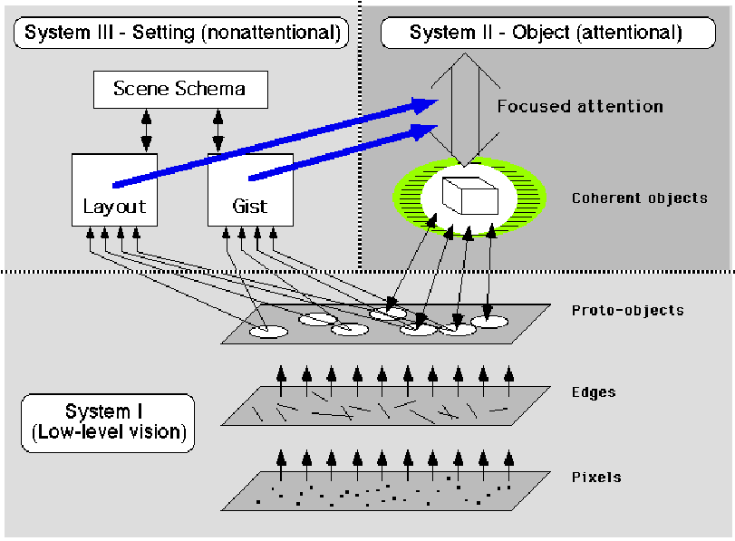
Figure 4: The “triadic architecture” of Rensink (2000). Three visual sub-systems provide converging evidence towards the understanding of a (static) scene: A fast and massively parallel low-level vision sub-system provides sufficient cues to guide attention and select locations which deserve further analysis by the object recognition sub-system; in parallel, the third sub-system operates a fast non-attentional evaluation of the scene’s gist and layout, to be used to further guide attention.
Obviously, scene understanding is more complex than just shifting attention onto conspicuous objects and sequentially recognizing them. In particular when one adds the dynamic component involved in recognizing actions in dynamic scenes, this topic, however, has seen relatively little emphasis in computational neuroscience research (Rizzolatti et al., 2001), certainly in a large part because the mechanisms for the top-down control of attention remain largely unknown (but see below, functional imaging studies). Thus, a reasonable view of the current state of the art in computational modeling of scene understanding is summarized in Figure 4, and highlights the current lack of comprehensive theory and biological model of how basic components such as attention, localized recognition, and gist or layout recognition may fit together into a robust, flexible and integrated system. Establishing constraints on such an integrated system, using psychophysics, functional brain imaging and modeling, is a major focus of the proposed research as we probe the relation of recognizing actions and related objects in a scene to the problem of scene description and answering questions about the scene.

Activity Recognition
There has been some research on event understanding in recent years (Brand et al., 1997; Bregler, 1997; Bremond & Medioni, 1997; 1998a; 1998b; Morris & Hogg, 1998). However, most of the current approaches are for developing specific systems for recognizing a single activity (or a small set of them) in a highly constrained environment. We are developing a flexible and generic representation of human activity that can apply to a variety of different behaviors in a variety of different environments. This project, carried out by the USC Institute for Robotics and Intelligent Systems (IRIS), has for prime objective the development of video-based monitoring systems, for example to be used in public buildings or parking lots. We shall use the term "activity recognition" for the work described in this section to distinguish it from the work on modeling the mirror system, which we have called "action recognition".
Human activities may be analyzed at various scales, such as observing facial expressions, body gestures or a group behavior in a global environment. We consider the recognition of the interactions of humans with other objects, including other humans, in the environment either by tracking the whole body in the case of a global event or by tracking parts of a human body individually in a smaller scale event. We will outline below some of the computational processes we have developed for activity analysis. Here, we stress our interest in linking analysis of activity in a visual scene to a verbal description. The link between the characteristics of the tracks of mobile objects (i.e., the whole body or a moving part of the body) and verbal space must be performed in a systematic way. We have begun with the formalization of the basic spatio-temporal characteristics of the tracks and propose to extend such notions to categorize activities. There has been extensive study on language, spatial cognition and vision in the linguistic and cognitive science community (Schirra, 1992; Sablayrolles, 1995; Herkovits, 1997). Our goal in this work on activity analysis (as distinct from the work proposed below) is to use a study of spatio-temporal verbs to provide hints on the types of activities a system will need to understand. In Herkovits (1997), English prepositions have been studied, classified and linked to human perception of simple movements of objects from their trajectories and reference objects (e.g., “moving across the road”, “moving along the path”, and “moving around the park”).

Functional Neuroimaging
A number of functional imaging studies have identified brain regions involved activated during the analysis of complex scenes. These include, for example, the hippocampus, parahippocampal gyrus, and inferior frontal gyrus (e.g., Menon et al., 2000). Similarly, the modulatory effect of attention and task demands on sensory processing has been widely observed (e.g., Gandhi et al., 1999). Several functional imaging studies have also focused on particular brain regions, e.g., for recognizing faces (Kanwisher, 2001) or actions (Rizzolatti et al., 2001). While these studies provide a consequent body of grounding data, we note that typically they have not yet been placed in perspective and tested against an elaborate computational architecture. Hence, one of the goals of the present studies is to carry out new functional imaging experiments, that will be directly guided by our modeling work and that will in turn help us constrain the architecture of our model and fine-tune its components and their interactions.

Preliminary Studies

Modeling the Mirror System
Our prior research has modeled mechanisms for visual control of grasping and aspects of the mirror system in the monkey brain. We developed the Synthetic PET/fMRI methodology to use models of detailed circuitry in monkey to predict results of human brain imaging (Arbib et al. 2000 for a review).
The FARS model (Fagg and Arbib, 1998; Figure 5) interprets these data by hypothesizing that AIP provides visually-based affordances to F5, and that selection by F5 of which affordance to act upon depends on input from prefrontal cortex (PFC) that in turn may depend heavily upon object recognition processes in inferotemporal cortex (IT). The FARS model has two primary components, the recognition of the object affordances and the selection by F5 of an appropriate grasp from this menu of affordances. The Mirror Neuron System (MNS) Model (Oztop and Arbib, 2001; Figure 6). has to recognize not only object affordances but also how the hand is moving and preshaping. Figure 1 showed regions of the brain that provide appropriate data for trajectory and preshape. The caudal intraparietal sulcus (cIPS) is provides information about the shape of the object that AIP needs to do its job looking at the orientation and so on of the surfaces of the object. Two other brain regions in Figure 6 are in the parietal cortex: PG, which seems to be particularly good at spatial coding for objects, including motion during interaction of objects as well as self motion, and PF which seems more related to somatosensory information, touch and so on but again related to mirror-like responses. STS (Superior Temporal Sulcus) is in temporal cortex rather than parietal cortex but seems to be very important in detecting biologically meaningful stimuli such as hand movements as well as having sub-regions MT and MST that encode motion related activity.

Figure 5. Overview of the FARS Model. Parietal area
AIP extracts the set of affordances for an attended object. Current empirical data stresses cases where there is only one affordance available; modeling points the way to new experiments by suggesting how F5 may select which affordance will be the basis for action by a Winner-Take-All (WTA) mechanism.
The WTA is biased by input from various areas of prefrontal cortex (PFC)including representations of task constraints based on object recognition information supplied by the area IT (inferotemporal cortex) of the "what" pathway.
The MNS model of Oztop and Arbib (2001) starts with a “brain” in which the F5 canonical neurons (i.e., the grasp-related motor neurons of F5 that are responsive to the sight of graspable objects but do not have the mirror property) are already controlling an interesting set of grasps and then has the mirror neurons learn to recognize how motion of the hand relative to an object correlates with F5 canonical neuron activity during self-generated movements. Along the top diagonal there is a portion of the FARS model. Object features are processed by AIP to extract grasp affordances, these are sent on to the canonical neurons of F5 that choose a particular grasp. The bottom right of the figure shows how recognizing the location of the object can provide appropriate parameters to another motor programming area – in this case F4, which is adjacent to F5 in premotor cortex – which computes the reach. The information about the reach and the grasp is taken by the motor cortex M1 to actually control the hand and the arm. The other schemas add the new functionality that allows the mirror neuron system to do its job. At the bottom left we have two schemas which may be localized in area STS of the monkey brain, one to recognize the shape of the hand of the actor being observed by the monkey whose brain we are interested in, and the other to recognize how that hand is moving. Just to the right of these is the schema for hand-object spatial relation analysis. It takes information about object features, the motion of the hand and the location of the object to infer the relation between hand and object, what we call the "hand state". Just above this is the schema for object associating affordances and hand state. The model shows how information coming from the F5 canonical neurons during the monkey’s own movements can be used to enable the F5 mirror neurons to learn how to recognize actions and how the mirror neurons are activated not only during the monkey’s own movement but also when the monkey observes a similar action by someone else.
This study provides a neurally grounded analysis of action recognition when the action is that of a hand grasping or manipulating an object. The proposed research must extend this in two ways. (i) To analyze how the recognition of hand movements may be extended first to recognition of communicative gestures of the hand and then to communicative gestures more generally (the Mirror System Hypothesis.); and (ii) To extend action recognition from hand movements and communicative gestures to actions more generally, thus providing the linkage of dynamic scenes to the verbal description of minimal subscenes within them, and of questions to the attention-directed search for relevant information in the scene.

Modeling Mechanisms of Attention
We recently developed a neuromorphic model of how our visual attention is attracted towards conspicuous locations in a scene. It replicates processing in posterior parietal cortex and other brain areas along the dorsal (“where/how”) visual stream in the primate brain, but with the emphasis on "where" an object, complementing the emphasis on "how to interact with it", and the recognition of such interactions, of the previous section. Because it includes a detailed low-level vision front-end (this is not true of the FARS and MNS models to date), the attention model has been applied not only to laboratory stimuli, but also to a wide variety of natural scenes (Figure 7).
Figure 6. The MNS model.
In addition to predicting a wealth of data from psychophysical experiments, the model demonstrated remarkable performance at detecting salient objects in outdoors imagery -- sometimes exceeding human performance -- despite wide variations in imaging conditions, targets to be detected, and environments. We completed the parallelization of the model, which now runs at 30 frames/s on a 16-CPU computer cluster. We are merging this model with a model from MIT of object recognition at one location (Riesenhuber & Poggio, 1999), based on the simulation of neurons in inferotemporal cortex and other areas along the ventral (“what”) visual stream. The combined model, of which a prototype is available, will provide both localization and identification of the few most interesting objects in a scene. This model embodies neural processing found along the “where/how” and some of the “what” processing streams, and thus complements the grasp-specific mechanisms of the FARS model.
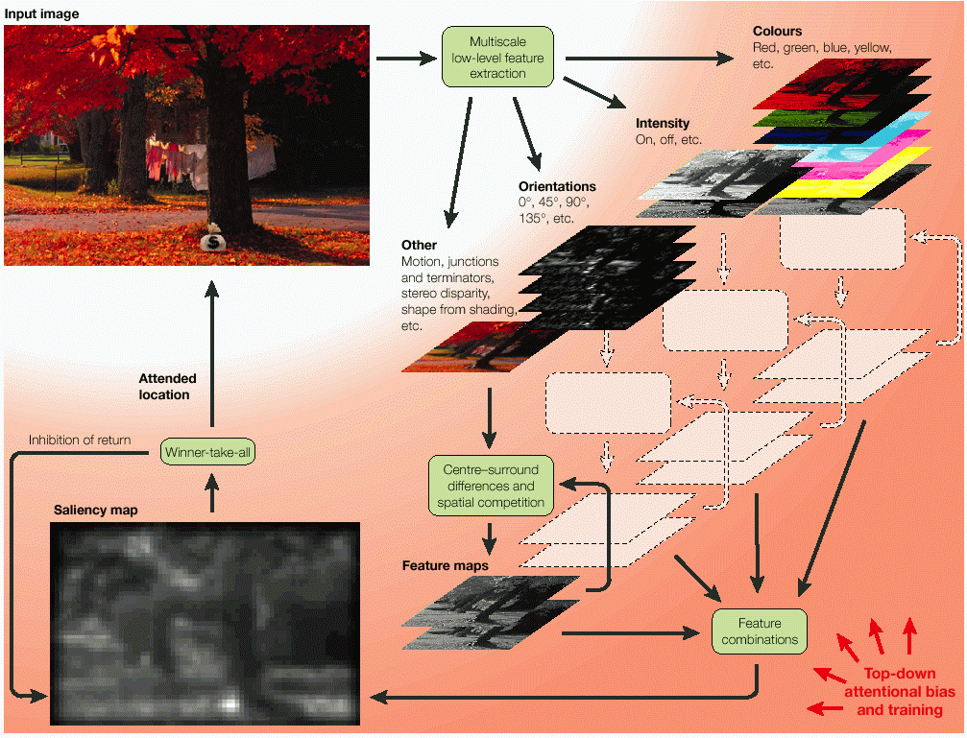
Figure 7: Overview of the bottom-up attention model. The input video stream is decomposed into eight channels (intensity contrast, red / green and blue / yellow double color opponencies, intensity flicker, and 0, 45, 90 and 135° orientation contrasts) at six spatial scales, yielding 48 feature maps. After non-classical surround suppression (Cannon & Fullenkamp, 1991; Sillito et al, 1995), only a sparse number of locations remains active in each map, and all maps are combined into the unique saliency map. The saliency map is scanned by the focus of attention in order of decreasing saliency, through the interaction between a winner-take-all (which selects the most salient location) and an inhibition-of-return mechanism (which transiently suppresses the currently attended location from the saliency map). This model matches or exceeds human performance on a variety of search tasks in natural scenes (see http://iLab.usc.edu/bu/).
Given video streams of natural environments, our current attentional system can attend to salient objects and recognize some of them. As such, this model already embodies a prototype combined where/what sub-system. As detailed below, our research will aim first at extending this model to a model of combined how/what visual processing (through integration with the FARS model). This will allow us, in particular, to explore more complex interactions between object/action recognition and attentional allocation. This how/what subsystem will provide input to the “minimal subscene” core, in the form of “rich scanpaths” comprising both localization and identity information. The challenge then will be double: First, to exploit these always changing and possibly noisy rich scanpaths such as to only allocate computational resources to those locations and objects/actions that are relevant to the current task; second, to devise more sophisticated mechanisms than are currently available to feed task-related information back into the how/what sub-system, in order to behaviorally (top-down) guide attention and recognition.

Modeling Activity Recognition
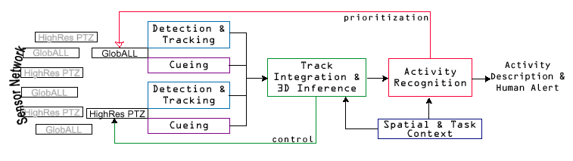
Figure 8: The USC/IRIS activity recognition system. Input currently is provided by a network of sensors (high-resolution pan/tilt/zoom (PTZ) cameras, and our GlobAll virtual cameras), and is fed into a detection and tracking sub-system that will benefit from integration with the attention and action recognition components. The system tracks moving objects in the video sequences, and progressively interprets object trajectories, in a hierarchical manner, yielding a symbolic description of those trajectories, their actors, and their interactions. Provision exists in the system by which top-down control may feed back to the low-level vision stages (e.g., to move the cameras towards actors of interest).
We have reviewed above our neurally grounded analysis of action recognition for hand movements and stressed the importance for our project of extending action recognition from hand movements and communicative gestures to actions more generally. We here summarize our recent work which achieves this within the domain of computer vision, providing key concepts for action recognition in general, and the extended recognition of minimal subscenes of which it is part. The tradeoff is this: the prior work on modeling the mirror system focuses on processing simplified visual input for a limited set of actions (a hand grasping an object), but does so in a way that is strongly linked to the data of neuroanatomy and neurophysiology. By contrast, the work on "activity recognition" focuses on processing realistic visual input for a broader set of actions (human activities; Figure 8), but does so in a way that has no connection to the data of neuroanatomy and neurophysiology. An important part of our research will be to combine both facets of our prior work to build a more general "action recognition" system that can process realistic visual input for a broad set of actions in a way that is strongly linked to the data of neuroscience.
In general, events can be viewed as consisting of single or multiple threads. In a single-thread event, relevant actions occur along a linear time scale (as is the case when only one actor is present). In multiple thread events, multiple actors may be present requiring consideration of logical and temporal constraints between the different threads. A single thread event may be further categorized into a simple or complex event. Simple events can be analyzed by considering the action sequence as a single coherent unit (e.g., “approaching an object of reference”) whereas complex events are composed of a consecutive sequence of other (simple or complex) activities. Figure 9 illustrates two similar but different complex events. Complex event Contact1 is a linear occurrence of three simple events: “approaching a person”, “stopping at the person” (or “making a contact”), and “turning around and leaving.” Similarly, complex event “Passing_by” is a linear occurrence of “approaching a person,” “passing by” and “leaving.”
This system will provide a basis by which we can bridge the gap between a high-level, symbolic description of a dynamic scene, its actors and its events, and the low-level vision information provided by the how/what sub-system. Our current work on activity recognition will thus guide the elaboration of the “minimal subscene” core of the proposed complete model. Indeed, it will establish the linkage between the output of the how/what sub-system and a textual description of the scene, its actors, and its events. Our proposed fMRI experiments will play a crucial role in seeing how the processes developed in our computer vision work must be transformed to yield hypotheses on how functionally related, but possibly quite different, processes, are instantiated in the human brain.
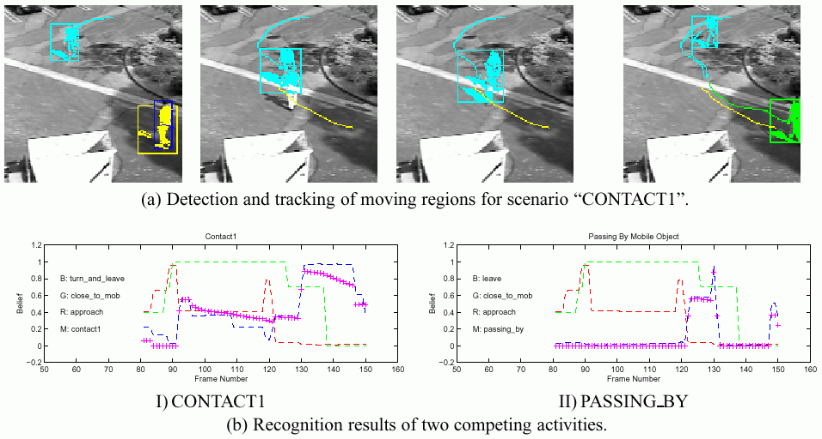
Figure 9: Single-thread, simple events are detected by tracking moving objects/actors. Combined evidence from several such events yields the recognition of complex, multi-threaded events such as “CONTACT1” and “PASSING_BY”.

D. Research Design and Methods
This proposal will probe the relation between brain mechanisms for action and language through a comprehensive integration of modeling, analysis of data on monkey brains, and new human studies. The grounding for this dual linkage - of monkey and human, and of action and language - is provided by the Mirror System Hypothesis: the primate brain's "mirror system for grasping" - central to the capacity to generate and recognize a set of actions - provides the basis for language parity, in which an utterance means roughly the same for both speaker and hearer. We propose to conduct experiments in human psychophysics to analyze behaviors linking action, action recognition and language, and new fMRI brain imaging studies to suggest and test hypotheses concerning the localization of key schemas constituting the variety of behaviors studied in greater parametric detail using psychophysics. To codify and explain the findings of these and related studies, we will extend our existing neural models of both the mirror system in monkey and of mechanisms of visual attention and our computer vision techniques for action recognition to chart the human brain mechanisms for recognizing, describing, and answering questions about interactions of actors and objects. The remainder of the research plan is divided into two parts:
Modeling: We propose to extend and integrate the computational components which have been developed by the PIs at the University of Southern California (Arbib: neural action recognition model, Itti: neural bottom-up visual attention model, Nevatia: computer vision activity recognition model), and to devise new components for minimal subscene representation, which, when brought together with the new, neurally consistent extensions of our existing components will yield the first complete model for dynamic scene understanding integrated with scene description and question answering. In separate subsections, we will outline our proposed modeling of minimal subscene description and of question answering, action recognition, saliency-based attention, activity recognition, and minimal subscene extraction. We then outline the considerations which will help us extend the above work to develop a mirror-system based neurolinguistics which will allow us to offer a new conceptual analysis of aphasia and apraxia.
Experiments. After describing the tasks we have devised to test human performance on minimal subscene description and recognition, question answering, and related attentional processes, we will outline our plans for visual psychophysics experiments at USC and functional magnetic resonance imaging at Brookhaven National Laboratory. The data from these experiments will provide constraining evidence from humans on how the interactions among our model components should be developed.

Modeling

Minimal Subscene Description and Question Answering
To focus the work, we will concentrate on the study of "minimal subscenes". The idea here is that the basic unit of action recognition requires us not only to see the underlying movement, but also who is executing the movement, and to what end. It may also involve recognition of the instrument of the action. We call this the "action-object frame" and our concern is with how this relates to the expression of this minimal subscene in language. Thus, a movement of the forearm up and down is a movement, but if it is Harry's forearm moving up and down as he holds a hammer, then we have an action which falls under the general action-object frame of Action(Actor, Patient, Instrument), with this particular example Hit(Harry, Nail, Hammer) which may be expressed in English which expresses the corresponding verb-argument structure as "Harry is hitting the nail with a hammer." We will thus ask how attention might first be focused, in this hypothetical example, on Harry and extend to recognition of his action and the objects involved, or start with the hammering movement and extend to recognition of the actor and objects that complete the minimal subscene. The aim is (i) to more deeply analyze the processes responsible for object recognition, action recognition and their integration in recognizing a particular scene, and (ii) to understand the way in which the generation and comprehension of simple sentences is intertwined with these processes. In particular, to get a window on comprehension, we will test - and model - the ability of subjects to respond to questions of the "Who is doing what and to whom?" variety while observing a picture or video clip.
The present section outlines our modeling of the "language system" for minimal subscene description and of question answering in a way which sets the stage for the modeling of action recognition, saliency-based attention, and activity recognition, new modeling of minimal subscene extraction proposed in the following subsections. As an example of the approach, we outline our initial hypothesis about the processes that may be involved in answering a textual question about the dynamic scene presented to it. Clearly, this hypothesis will be updated, and linked to hypothesis about the roles of different brain areas, as modeling and experimentation proceeds:
- Analyze the question to determine what objects and actions and what "slots" need to be filled. As detailed below, we will restrict our work by using a limited set of "sentence frames" of the "Who is doing what to which" variety rather than addressing the general parsing problem.
- Look for those relevant objects and actions using a combination of bottom-up and top-down attention and object/action recognition;
- Construct the “minimal subscene,” that is, a dynamic, topographic-based representation of the few objects, actions and actors that are relevant to the current task (as defined by the question asked to the system);
- Generate a description and/or answer the question, in terms recognized events ranging from simple, single-threaded events involving just one object or actor to more complex multi-threaded events involving several interdependent sequences of objects/actions/actors.
We will also study a "scene description" mode for the system, an autonomous, bottom-up mode in which the attention sub-system can keep focusing on various conspicuous objects, actors or actions throughout the scene, and attend to new details which enrich the minimal subscene. The challenge here is to achieve a rich set of insights without taking on a subproject of unbounded complexity which must confront all the challenges of neurolinguistics:
(i) Our linkage of the recognition of minimal subscenes to descriptions and questions will involve the detailed modeling of neither the perception of the auditory signal nor of the control of the vocal apparatus. Our earlier work on the FARS model sets a useful precedent. There, we did not seek to analyze processes that start with realistic retinal input (in contrast to the proposed research where the processing of pictures and video clips will be central to our modeling). Instead, we started with a quasi-realistic representation of the affordances for action in AIP, and showed how these could, via the involvement of many brain regions, result in the pattern of premotor activity in F5 which provided the population code for action. In the same way, we will start with the encoding of the recognition of words in the parietal cortex (e.g., Wernicke's area) and end with the encoding of word production in premotor cortex (e.g., Broca's area)
(ii) We do not attempt to parse or produce complex sentences which include tense markers, conditionals, relative clauses, and other subtleties. By restricting ourselves to minimal subscenes which can be represented by standard action-object frames such as Action(Actor, Patient, Instrument) for which English offers a straightforward corresponding verb-argument structure – just as Hit(Harry, Nail, Hammer) may be expressed as "Harry hits the nail with a hammer." – we can focus on the key linkages between action and scene recognition and verbal expression. However, we will study two basic extensions of the core verb-argument structure. (a) We will study the extent to which the initial focus of attention may modulate verbal expression: e.g., "Harry hits the nail with a hammer" versus "The nail is being hammered by Henry". (b) We will study the way in which "attention zooming" interacts with detail of description: e.g., "It's a ball", "It's a red ball", or "It's a large red ball." And, of course, we will study the dual questions for question-answering as we test - and model - the ability of subjects to respond to questions while observing a picture or video clip.
Thus, we will focus on a limited inventory of "sentence frames" rich enough to encompass the majority of questions we will ask and sentences our subjects will generate. Indeed, in the early stages of setting up the psychophysics experiments, we will postpone the detailed measurement of response times and eye movements, and simply try out a variety of paradigms to elicit a corpus of scene descriptions from subjects. Analysis of this corpus will enable us to delimit the inventory of sentence frames used in our study. Each such frame may be seen as a hierarchical structure in which extended attention to a given component of the scene extends the complexity of the constituents in the parse tree of the sentence.

Saliency-Based Attention and Action Recognition
The work proposed here on attention will complement Itti’s research under other funding on the interaction between attention and object recognition and Arbib's research under other funding on modeling the monkey mirror system by emphasizing the challenge of recognition of actions as well as objects as the basis for minimal subscene representation. Thus, our specific aims for further modeling of the attention sub-system are: (i) To extend our attention model from where/what to how/what by including action recognition, as provided by the FARS/MNS model (referred to as the MNS model below, for brevity); (ii) To develop a simple on-line top-down biasing mechanism to location and feature (including motion features), such that the attention sub-system can be primed based on task demands as in question answering; and (iii) To enhance the model to focus not only on a location, but also on increasing detail at that location.
Extension from where/what to how/what: Currently, the saliency-based attention model processes raw video sequences and determines the spatial location of conspicuous targets. Image regions around these targets are then fed into an object recognition module. At present we have 2 object recognition models (Miau & Itti, 2001; Miau et al., 2001): one yields very robust recognition performance in natural scenes for tasks such as, for example, the recognition of pedestrians in outdoors imagery (Papageorgiou et al., 1998), but has little biological relevance; the second (HMAX) is motivated by the neurobiology of the primate ventral processing stream, but not yet as robust with natural images (Riesenhuber & Poggio, 1999). Under other funding, we will further integrate the latter object recognition model to the attention model. We propose to carry out a parallel integration effort here, merging the FARS/MNS model to the attention/recognition model. Specifically, we will extend the detailed low-level vision front-end of the attention model to include additional low-level features required by the MNS model. Spatio-temporal motion energy will be implemented under other support; here we will focus on object segmentation, and temporal continuity and tracking.
Object segmentation: An outline of the recognized object is required by the MNS model, so that it can accurately infer object affordances and also recognize hand shape and hand motion. It thus requires object segmentation for both the "what" and "how" pathways. The hierarchical architecture of the HMAX object recognition model provides ideal grounds for such differentiation between object and background. Thus far, HMAX is a purely feedforward architecture, in which several neural processing layers process the input image region such as to progressively increase both feature complexity (e.g., from simple edges at the first layer, to combinations of such edges in further layers) and invariance (with respect to translation, rotation and scale). At the top layer (representing inferotemporal cortex, IT), neurons are tuned to specific views of objects. We will extend this in the light of Figure 1 to show how, for example, feature representations in cIPS may be differentially involved in IT's object recognition and AIP's extraction of affordances.
We will extend the present model through the implementation of a feedback processing path, using an architecture derived from the hierarchical winner-take-all architecture of Tsotsos et al. (1995). In that model, objects in the input image give rise to spatially coarsely-defined feedforward activation across a hierarchy of processing layers; an object of interest is then selected at the top layer, and an “inhibitory beam” is then propagated back towards the bottom (input) layer, which refines the initially coarse spatial definition of the object of interest. The model has so far been applied to attention focusing and enhancement of the attended object in a scene; we will use a similar strategy to implement the proposed object segmentation algorithm.
Temporal continuity and tracking: Thus far, the only memory in the attention model is the dynamic topographic saliency map, which integrates saliency information over space and time (not considering the object template memory that is used for view-based object recognition). The saliency map is scalar, that is, represents a single quantity that is salience at a given location. Such representation is too poor for reliable tracking of moving objects in video sequences, which is required as an input for the STS and PF components of the MNS model. In addition, there is mounting experimental evidence that inhibition-of-return (the process by which the currently attended object is suppressed so that attention can shift to the next most salient object) is object-bound; that is, if an object is moving across the visual field and is attended to, it will not attract attention again for some time, even though it will appear in subsequent frames at locations different from the one where it was suppressed (and thus should, in principle, yield a high salience signal at these new locations). Developing such object-bound inhibition-of-return would indeed greatly enhance the performance of the attentional system, enhancing temporal continuity in the object recognition process.
To this end, we will implement a “blob-tracking” algorithm which will follow, in the saliency map, all recently attended locations (blobs, or shapes as back-projected from the recognition model). In a first step, this algorithm will use simple region-growing and 2D connectivity operators to segment salient blobs in the saliency map; as progress is made on the integration of object recognition and attention, however, the initial blob segmentation will be replaced by a more precise segmentation derived from the object recognition pathway. To integrate dynamic tracking of previously attended objects, we will have to split the current unique saliency map into three neuronal processing layers: the saliency input from the feature detection stages, an inhibition-of-return layer containing all the blobs being tracked, and the actual saliency map containing the saliency input minus the inhibited blobs. The blobs will then be tracked through the interplay of the saliency input and inhibition-of-return layers. In later we will consider whether the brain employs a single set of such processes for use by both inferotemporal and parietal pathways, or whether such processes occur (perhaps with several different specializations) in both pathways (each of which is a complex network rather than a broad pathway).
On-line top-down biasing: Thus far, we have successfully demonstrated how the attention model could be trained to specific search tasks (e.g., find traffic signs or military vehicles in outdoors imagery) by implementing a very simple top-down bias consisting of learning, in a supervised manner, the set of weights by which each feature map contributes to the saliency map (Itti & Koch, 2000, 2001jei). We propose to extend the saliency system, such as to become able to learn sophisticated interactions between channels. Indeed, our ongoing research on attentional modulation of early sensory processing has shown that attention has a strong modulatory effect on intracortical connectivity. For example, we have recently developed a model of a single cortical hypercolumn in primary visual cortex, and been able to predict human psychophysical pattern discrimination thresholds for five different tasks using this model; we then found that the apparently complex and disparate modulatory effect of focal attention on those five tasks (32 thresholds) could be explained by a single computational mechanism, by which attention activates a winner-take-all competition across all neurons in the hypercolumn (Lee et al, 1999; Itti et al., 2002nips). We will implement connections across channels by which each feature map at a given scale can receive both additive and multiplicative excitatory or inhibitory input from another feature map at same or different scale. These connections will extend the iterative spatial competition for salience already implemented in the saliency model (Itti & Koch, 2000vr; 2001jei).
We believe that this extension of our model will be particularly powerful and useful in providing robust “rich scanpaths” to the downstream components of our final complete model, as it will allow for unsupervised on-line adaptability of the attention system to various types of targets, of clutter, of illumination conditions and of environments. Alternatively (cf. Edelman & Intrator, 2001) we will represent objects by spatial graphs indicating the relationship between key intermediate-level features of the object. Such a representation can be built up by repeated scans of the object; subsequent recognition will follow from the generation of any scanpath which visits and verifies a critical subset of the representing graph. The proposed refinement of our model should provide sufficient new degrees of freedom to allow top-down cueing to locations and objects with performance that approaches human performance, such that more complicated top-down biasing of the low-level visual processing layers may not be necessary.
Attention to details: As already mentioned, the output of the combined how/what subsystem will be rapid streams of localization and recognition information, which we describe as “rich scanpaths.” We here propose to enhance this representation by providing top-down signals by which the low-level vision front-end may be instructed to focus onto objects and actions of a specific size or magnitude, in addition to the feedback signals proposed in the previous paragraphs, which emphasized features. Currently, the focus of attention is represented as a circular window with fixed diameter. Once an object or actor has been recognized and feed to the minimal subscene component of our final model. However, further analysis and understanding of how this object/actor relates to other objects and actors in the scene may require to specifically focus on parts of the object or actor. For instance, if a person has been detected but the task dictates that only the person “John” is of interest, such task demand should translate into an instruction to the attention/recognition sub-system to next focus on that person’s face rather than on the whole person. This will be made possible through three mechanisms: biasing the low-level visual processing towards features that are characteristic of faces (through the mechanisms mentioned above), towards a specific location (see below for the notion of “task map” which defines regions of current interest in the scene), and towards a scale that also coarsely matches the person’s face and that can be computed from the known scale of the detected person. In addition to a mere scaling of the diameter of the focus of attention, this new enhancement will exploit the inherently multiscale architecture of our model, by enhancing those feature maps which correspond to scales that are relevant to the object of interest. With this proposed resolution/scale priming, the attention subsystem will become more efficient at delivering, in its rich scanpath output, those objects or object parts that are of current behavioral relevance. To link this back to integration with the MNS model (and to serve as a reminder that these processes are important for the "how" as well as the "what" pathway), we note the importance of "attention to details" to AIP's extraction of affordances: having attended to an object, how does one then attend to the graspable parts of that object?

Activity Recognition
The activity recognition system represents the highest level of abstraction in our analysis of minimal subscenes and will, at least in our initial modeling prior to the incorporation of fMRI based constraints on the possible subprocesses and their localization, provide the representations that will interfaced with language modules for minimal subscene description and question answering. The system will interpret sequences of groups of single simple events within a hierarchical and composable framework leading to the understanding of complex multi-threaded events. In its current form, it does not provide a biologically-plausible implementation. Thus, our specific aims for further modeling on this topic are (i) to use the current activity recognition system as an inspiration to help us develop the initial symbolic subscene core; and (ii) as the basis for extending the MNS model towards the capability of the activity recognition model, but in neural form.
To bridge the gap between a high-level, symbolic description of an activity and the signal-level information provided by the attention and action recognition sub-systems, we propose a hierarchy of entities. Image features are defined for regions of interest in the images. Mobile object properties are defined for the moving regions and are based on their spatial and temporal characteristics. Scenarios correspond to long-term activities of mobile objects such as “a person walks along the corridor and falls down on to the ground.” They are described by the class of the objects (e.g., a human or a car) and the events, either single-thread or multiple-thread, in which they are involved. Scenarios are defined from a set of properties or a set of sub-scenarios. The structure of a scenario is thus hierarchical. Mobile objects are defined from the moving regions tracked by the action recognition sub-system. We define two groups of mobile object properties: Object characteristic properties correspond to the instantaneous characteristics of the moving blob that represents an object. Some mobile object properties are elementary (e.g. width, height, color histogram, texture or principle axis) while the others can be complex (e.g. a graph description of the shape of an object); while trajectory related properties are computed from the trajectory of the mobile objects (e.g., the direction of the trajectory or the object speed).
A source object is a mobile object that performs an action (the Actor in our action-object frames), the reference is another object belonging to the scene context (filling the other frame roles. Mobile object properties can be computed robustly at each time frame by incorporating their temporal properties (e.g., temporal consistency of property values over time). A filtering function and a mean function that compute a mean value based on the multi-Gaussian distribution of the property values collected over time are available to minimize the errors caused by environmental and sensor noise. Simple, single-thread events (or simple events) correspond to a single, coherent unit of movements, which is performed by one agent (or a group of agents acting in the same manner). However, a simple event can be described by sub-events: “a person is slowing down toward an object” breaks down to “the person is getting closer to the object,” “the person is heading toward the object,” and “the person is slowing down.” The hierarchical representation of a simple event can be viewed as an instantiation of a causal network (or a Bayesian network; Pearl, 1988). Complex, single thread events(or complex events) correspond to a linearly ordered time sequence of simple events (or other complex events). For example, complex event “Contact1” is described as a linear occurrence of three consecutive simple events: “a person slows down towards another person,” then “stops at that person,” and then “turns around and walks away.” We propose to use a finite-state automaton to represent a complex event because it allows a natural description (Goddarrd, 1994; Bremond, 1997; 1998a; 1998b). Multiple thread events correspond to two or more single-thread events with some logical and time relations between them. Each composite thread in a multiple thread event may be performed by different actors. We propose to use the interval-to-interval relations, first defined by Allen (1984), such as “meets,” “before,” “starts,” “finishes,” “during” and “overlap,” to describe temporal relations between sub-events of a complex events. For example, “Event A must occur before event B,” “Event A must occur and event C must not occur,” and “Either event A or event D occurs.”
We have developed an Activity Representation Language (ARL) that can represent a variety of simple and complex events. The task of adding new event descriptions can be speeded up even more by the development of a declarative Activity Representation Language (ARL) that allows a developer to build a new scenario in a more efficient and natural way, and also to catalog them for convenient reuse. ARL would allow specification of temporal and logical relations among sub-events of a complex or multiple thread event. Simple events would be specified in terms of object properties which would in turn be related to the structured video representation to be computed by the detection and tracking algorithms. Our expectation is that the events expressed in ARL can be parsed and transformed automatically into a program that computes the likelihood of that event having occurred in a given video sequence.
Having said this, our challenge is two-fold: one is to explore the extent to which the efficacy of the ARL in a computer vision system can be transferred to a brain model consistent with the results of our proposed experimental studies. The other is how such internal representations can be linked to language perception (understanding a question) and generation (describing a scene answering a question). Here we focus on the symbolic computations which will dominate our initial work on linking activity recognition to language. Below, we will offer general considerations on neurolinguistics which will frame our approach in later years towards the development of neurally realistic systems which achieve comparable functions, but probably with strategies at best inspired by, rather than closely constrained by, our preliminary models.
Attempts to link natural language to actions in simulated environments in artificial intelligence research focus on use of natural language and do not consider the complexities related to the analysis of real image sequences. In recent work, Kollnig et al. (1994) have developed a grammar to represent some driving activities on a highway from elementary road vehicle maneuvers but this language is restricted to such events. Bobick (1998) has proposed use of stochastic context free grammars. Our approach has similarities to this work but is distinguished by our use of underlying computational mechanisms to which the language needs to translate. The task of activity recognition consists of making inferences about the events taking place in a scene from the video images. This includes computing the entities described in the representation above. Figure 9 shows our approach schematically. Moving objects are detected and tracked in the video images and the spatial and temporal properties of the mobile objects are computed. These properties, in conjunction with spatial and task context are used to compute the likelihoods of various possible scenarios. A utility analysis can be applied to these likelihoods to decide on the optimal course of action (which may consist of just notifying a human or to take a corrective action). Computations at each level are inherently uncertain, hence a formal uncertainty reasoning mechanism is needed. Feedback from the higher levels to the lower levels may also be required to overcome some errors.

Minimal Subscene Extraction
The rich scanpaths provided by the vision component of our model will contain many false positives for a given task or behavioral goal, just as we attend to many irrelevant locations when we move around in the world. Somehow, we know how to quickly discard irrelevant objects and keep track of relevant ones, based on our current behavioral priorities. Thus, in order to become able to exploit these ever-changing rich scanpaths, we will develop algorithms to prune them depending on behavioral demands, such as to extract a stable "minimal subscene" representation that is task-dependent and locally stable over time. In contrast to existing models of scene analysis, such as those of Ryback et al. (1998) or Schill et al. (2001) reviewed above, we hypothesize that the minimal subscene may be represented spatially, in the form of a topographic map, which we term “task map.” Such a representation might be like the spatial graphs mentioned earlier but now extended to include links that express the dynamic relations of moving objects engaged in a coherent activity, using terms providing by the developing ARL of the previous section.
This hypothesis is based on the existence of many such topographic maps in the primate brain, and parallels the hypothesis at the basis of our attention model that salience might be encoded explicitly in a topographic map. Scanpaths, then, are just how information comes in, but not the representation used for processing. The specific research issues that we will address are (i) To understand what representation combines a topographic representation with the dynamics of ongoing action; (ii) To develop algorithms by which rich scanpaths can be pruned and to build an extended topographic representation for the minimal subscene; (iii) To interface this central component of the model with vision; and (iv) To interface with language through the activity recognition sub-system.
From rich scanpaths to the minimal subscene: Figure 10 outlines our current tentative view of the full integrated model. The central element is the “task map”, which must augment a spatial weighting of those regions that are of current interest, with some associated identification labels, with movement information relevant to the current activity. The saliency map weighted by the task map allows new objects to be attended to and known objects to be re-attended to, and will depend crucially on the tracking components referred to earlier. The task map is subject to top-down modulation depending on instructions and on what has been recognized and identified as being task-relevant so far. In addition to the task map, the minimal subscene core comprises a working list of objects/actors/actions that are of relevance to the current task. At least in a first step, this working “task list” will be represented symbolically, but once its role, structure and function are better understood through implementation and testing, we will also explore how it could be implemented in a biologically-plausible manner. The task list is structured, that is, it contains hierarchical collections of concepts linked by simple relationships, such as being a part of, an instance of, etc. (see example below). Concepts in the task list are inter-related to other concepts and linked to physical attributes of the corresponding objects/actors/actions through the knowledge base. These physical attributes are stored in the “what memory” which is used not only for recognition of objects and actions, but also for determining spatial correspondences and size relationships between objects and their parts, as well as low-level features that are characteristic of those objects. This low-level feature and size information is used to provide the top-down biasing signals to the visual sub-system. The “agent” is very simple at first and simply embodies the scheduling according to which the various components of the system interact (for example, obtain new object/actor/action from task map; then update task list accordingly; then map back contents of task list onto task map and low-level vision, etc). Not all interconnections and information flow paths are shown in the figure (in particular, feedback biasing signals towards the low-level vision modules are omitted).
To illustrate how the full system may function, we consider the following simple example:
i) Assume the generic question “what is John catching?” addressed to the system currently looking at a video clip of John catching a ball. Initially, assume an empty task map and an empty task list;
ii) The question will be mapped onto a sentence frame which allows the agent to fill some entries in the task list, which correspond to concepts specifically mentioned in the question as well as related concepts. Related concepts will be derived from the specific question concepts through the knowledge base, which simply is a database of concepts known to the systems and simple relationships among those (that is, an “ontology” similar to those that the PIs are developing in research projects that are concerned with neuroscience data mining and neuroinformatics (Arbib and Grethe, 2001)).
iii) In our example, initial entries to the task list might be: “John [AS INSTANCE OF] human(face, arm, hand, leg, foot, torso)” (all derived from “John”) as well as “catching, grasping, holding” (derived from “catching”) and finally “object(small, holdable)” (derived from “what”).
iv) The current task list would then create top-down biasing signals directed towards the vision components of the model, by associating the abstract concepts present in the task list to low-level image features present in the “what memory” that is also used for recognizing objects, actors and actions. For example, the what memory for “person” may contain strong vertically-oriented features, which would thus be emphasized in the low-level visual processing. Similarly, the “catching” action would emphasize some of the motion feature maps. In more complex scenarios, not only low-level visual features, but also feature interactions, spatial location, and spatial scale and resolution may thus be biased top-down, through the mechanisms described in our proposed extension of the attention/recognition subsystem.
v) Suppose that the visual system first attends to a bright-red chair that is present in the scene and that is the most salient object based on bottom-up cues (despite the top-down biasing commands). Going through its current task list, the system would determine that this object is most probably irrelevant (not really “holdable”) and would discard it from further consideration as a component of the minimal subscene. The task map and task list would both remain unaltered.
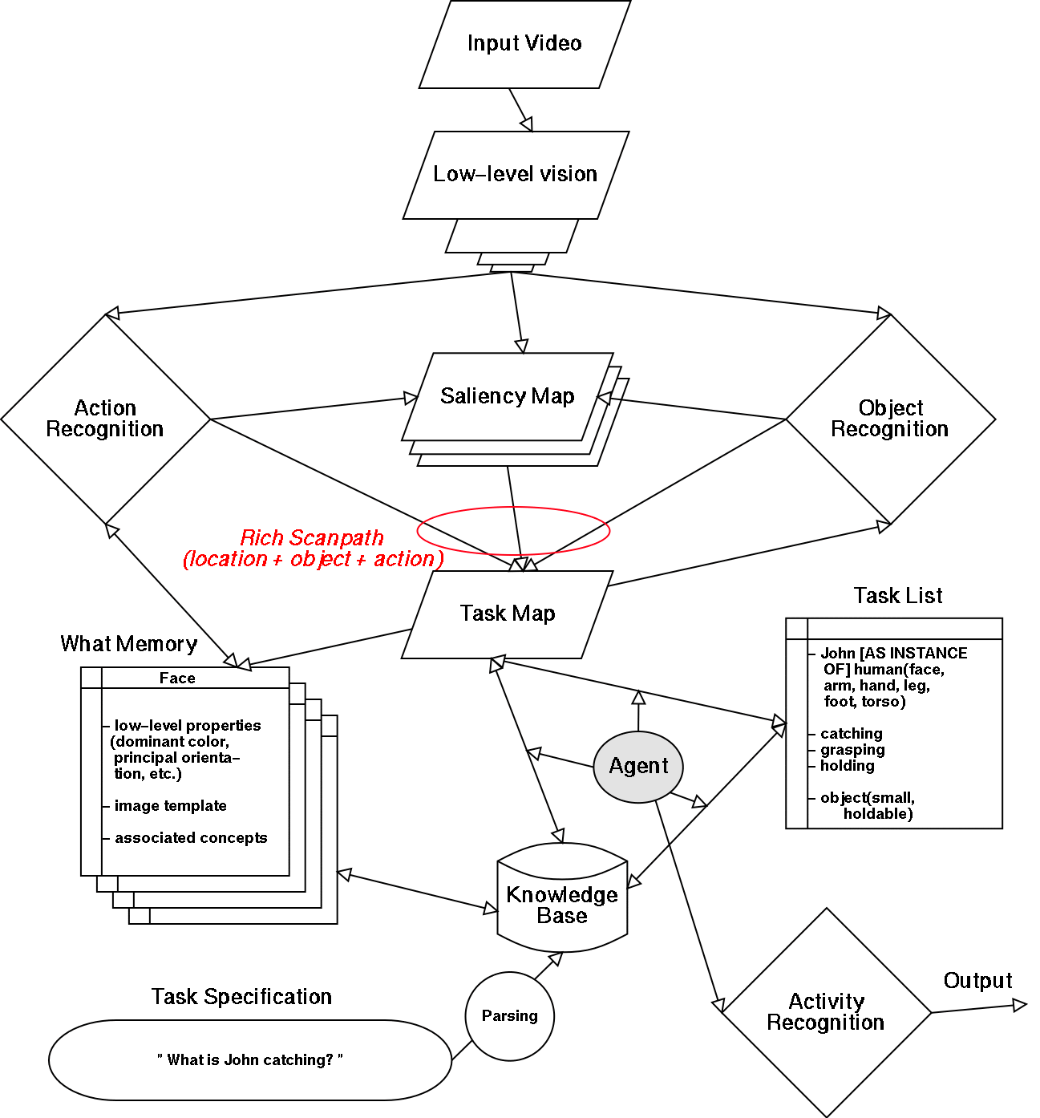
Figure 10: Proposed architecture for our complete model.
vi) Now suppose that the next attended and identified scene element is John’s rapidly tapping foot. This would match the “foot” concept in the task list. Because of the relationship between foot and human known through the system’s knowledge base, the system would now be primed to look for a human in a region that overlaps with the detected foot but is larger (and how large is stored in the what memory associated with human, scaled by the scale of the identified foot). In addition to feature bias, spatial bias would be sent to the vision subsystem and the task map would also mark this spatial region as part of the current minimal subscene. Similarly, once the human is detected and identified, the system would then look for its face (assuming that the knowledge base specifies that resolving “? [AS INSTANCE OF] human” can be done by looking at the face of the human). Once John has been localized and identified, the entry “John [AS INSTANCE OF] human(face, arm, hand, leg, foot, torso)” would be simplified into a simpler entry “John [AT] (x, y, scale)”. Further visual biasing will not attempt to further localize John nor his body parts (but in a more sophisticated version of our example, “catching” may also expand into looking for hands).
vii) If the system then attends to the bright green emergency exit sign in the room, this object would be immediately discarded because it is too far from the currently activated regions in the task map. Thus, once non-empty, the task map acts as a filter that makes it more difficult (but not impossible) for new information to reach higher levels of processing, that is, in our model, matching what has been identified to entries in the task list and deciding what to do next.
viii) Assuming that now the system attends to John’s arm motion, this action would pass through the task map, be related to the identified John (as the task map will not only specify spatial weighting but also local identity), and, using the knowledge base, what memory, and current task list the system would prime the expected location of John’s hand as well as some generic object features.
ix) If the system attends to the flying ball, it would be incorporated into the minimal subscene in a manner similar to that by which John was (i.e., update task list and task map).
x) In complement to the components of the system described so far, a last component is crucial in closing our simple example, that of activity recognition. The various trajectories of the various objects that have been recognized as being relevant, as well as the elementary actions and motions of those objects, will feed into the activity recognition sub-system, which will progressively build the higher-level, symbolic understanding of the minimal subscene. This component will put together the trajectories of John’s body, hand, and of the ball into recognizing the complex multi-threaded event “human catching flying object.”
xi) Once this level of understanding is reached, the data needed for the system’s answer will be in the form of the task map, task list, and these recognized complex events, and these data will be used to fill in an appropriate sentence frame and apply the answer.
This simple scenario already raises several outstanding issues, e.g., how can the system know that it has sufficient information to answer the question? To eliminate this problem at first, we will simply use video clips of fixed length and consider the internal contents of the model at the end of the video clip as being the model’s answer. Another issue is formulating a more user-friendly reply based on the model’s internal state, which we will also not address at least in our first attempt at building the model. Instead, the system’s reply will be its internal state. Finally, the design of the agent may become fairly complex as more complex scenes, knowledge base, and questions are considered. Starting with very simple questions such as “who is doing what to whom?” will, however, allow us to realistically bootstrap the development of the agent.
Note that we have bypassed the issue of using gist and layout information to guide scene understanding (see Figure 4). Indeed, how humans can infer the gist of a scene in a few hundred milliseconds remains a fairly open issue (e.g., VanRullen & Thorpe, 2001). It is probable that we will attack this issue fairly soon under other funding; attempting to also solve this problem in the current proposal would, however, be unrealistic given the available resources. In the absence of gist and layout information to provide coarse spatial guidance to the attention sub-system, we expect that our system will be less efficient than humans, because it will attend to a number of obviously irrelevant (by their position within the layout; but nevertheless salient) locations. However, we believe that the proposed core architecture is robust enough to perform despite those extra irrelevant attended objects/actions/actors.
The architecture detailed above uses a number of symbolic representations and algorithms (e.g., for the knowledge base and the agent), which will be developed in a manner very similar to the current activity recognition sub-system (i.e., using standard database tools and the LISP programming language). This is not our long-term research and implementation goal, however, but just a starting point. The above example makes clear that many internal processes are involved in the task, and that the study of eye movements will be crucial in providing a window on these. Our data on those processes that have overt correlates will anchor our hypotheses on the hidden processes that will support them. We also note that, whereas this scenario defers generation of the verbal response to the last stage, subjects may generate their answer in pieces as visual analysis proceeds. Thus our psychophysical data will include timing of each word of the response. In this way, psychophysics will provide key hypotheses on the processes involved in these tasks and the way in which they are coordinated, taking us from a purely computational model to a psychological model. This in turn will lay the basis for our neurological model as we develop hypotheses on neural localization and test them with our fMRI studies, feeding the results back to refine and further develop our model.
With the initial version of our complete model, we will already be able to study and fine-tune mechanisms by which current scene understanding may feedback onto low-level topographic feature maps and their interactions, and to implement, test and validate the overall architectural paradigm. Once neural implementation constraints become available from our experiments with human subjects, it will be particularly exciting to investigate possible neural implementations of the various components of the minimal subscene core. In the long term, for example, we aim at entirely eliminating the purely symbolic task list and knowledge base from the system. This will require a much richer representation for the task map and the “what memory,” in order to make the representation of “concepts” implicit. The task map will then become a multi-layered map, representing not only spatial weighting for location and some symbolic tagging of object/actor/action, but more directly interacting with the neurons in the what memory. Exactly how this will become possible will depend not only on our experimental results, but also on accumulated experience and understanding using the initial version of our complete model.
Interface with vision: The minimal subscene core not only receives input from the visual sub-system in the form of rich scanpaths, but also feeds back towards low-level vision via top-down biasing signals. The research challenge here will thus consist of deriving topographic and feature-based feedback signals from the symbolic information contained in the task list. This will require that spatial and feature information be stored in the “what memory” so that it can be associated with symbolic concepts.
Interface with language: We will largely simplify the interface between the language component (which receives and parses the question asked to the system) and the minimal subscene core by focusing on a basic set of sentence frames. We may offer preliminary analyses of more general syntactic processes in Years 4 and 5, but this will be more as a foundation for later research than as an explicit goal for the proposed work.

Towards a Mirror-System Based Neurolinguistics
The modeling of the monkey will provide insights into detailed neural circuitry of many of the basic processes of action recognition and attention; the Mirror System Hypothesis will guide our development of initial hypotheses about how comparable circuitry in the human brain achieves recognition of a far broader class of minimal subscenes than those involving a hand grasping an object, and how mechanisms for the generation and recognition of actions are then reflected into mechanisms for the production and perception of sentences. Data from collaborating labs working on monkey neurophysiology and neuroanatomy (e.g., Arbib has a continuing collaboration with the Rizzolatti lab) will be continually analyzed to better ground the developing model of monkey circuitry; our own psychophysical studies will provide detailed timing and eye-tracking data from experiments designed to tease apart the attentional, perceptual and linguistic processes in the various tasks of interest to us; and our fMRI studies will be designed to assess the relative activity in different regions of the human brain.
The human model will be richer than the monkey model because it must, in addition to general primate mechanisms, provide powerful mechanisms for the formation and explicit combination of symbols, using action representation, recognition and action as basis for semantic and syntactic representations. Where the previous 2 sections emphasized the strategy "Start with a symbolic solution of the problem of interest", the present work will adopt the strategy: "Start with a neurally realistic model of a core set of processes; then incrementally extend the core model as we understand the symbolic solution to various problems, and develop strategies to neuralize processes with comparable collective functionality". We will analyze homologies between the monkey and human brain to maximize the transfer of insights from monkey studies to the human brain - we have developed a Neurohomology Database (Bota and Arbib, 2001) for this purpose, and are in communication with Massimo Matelli of the University of Parma for data on homologies of the frontal (including premotor) cortex, and with George Paxinos of the University of New South Wales for data on homologies of the parietal cortex. We will use our Synthetic PET methodology (Arbib et al., 1995) as extended to fMRI (Arbib et al., 2000; see also Tagamets & Horwitz, 1998, 2000) to register predictions made with our computational models of the neural networks against imaging studies of the human brain regions involved in the attentional and other processes involved in recognition of actions and minimal subscenes and in the production and perception of sentences. The result will be a far deeper understanding of the relation between brain mechanisms of action and language which will provide a new framework and set of tools for the analysis of aphasia and apraxia and their relationship.
Our diagram of the MNS model showed that the monkey needs many brain regions for the mirror system for grasping. We will need many more brain regions for an account of language-readiness that goes "beyond the mirror" to develop a full neurolinguistic model that extends the linkages beyond the basic F5 ≈ Broca’s area homology. To complement the earlier conceptual analysis of minimal scene description in setting the stage for the future development of such a model, we briefly link our view of AIP and F5 in monkey to a key data point on human abilities, Goodale et al.'s (1991) patient (DF) with damage to the inferotemporal pathway. DF could grasp and orient objects appropriately for manipulating them but could not report – either verbally or by pantomime – on how big an object was or what the orientation of a slot was. Our mirror approach to language suggests a progression from action to action recognition to language as follows:
- Pragmatics: object  AIP  F5_{canonical}
- Action recognition: action  PF  F5_{mirror}
- Scene description: scene  Wernicke’s  Broca’s
The "zero order” model of the Goodale et al. data is:
- Parietal “affordances”  preshape
- Inferotemporal (IT) “perception of object”  pantomime or verbally describe size
However, (5) seems to imply that one cannot directly pantomime or verbalize an affordance; one needs the "unified view of the object" (IT) before one can communicate attributes. The problem with this is that the “language” path as shown in (5) is completely independent of the parietal → F5 system, and so the data seem to contradict our view in (3). To resolve this paradox, we note the psychophysical data of Bridgeman (1999; Bridgeman, Peery & Anand, 1997). In their experiments, an observer sees a target in one of several possible positions, and a frame either centered before the observer or deviated left or right. Verbal judgments of the target position are altered by the background frame's position but "jabbing" at the target never misses, regardless of the frame's position. The data demonstrate independent representations of visual space in the two systems, with the observer aware only of the spatial values in the cognitive (inferotemporal) system (Castiello et al., 1991). Bridgeman et al. have also shown that a symbolic message about which of two targets to jab can be communicated from the cognitive to the sensorimotor (parietal) system without communicating the cognitive system's spatial bias as well. We thus hypothesize that the IT "size-signal" has a diffuse effect on PP – it is enough to bias a choice between 2 alternatives, or provide a default value when PP cannot offer a value itself, but not strong enough to perturb a single sharply defined value when it has been established in PP by other means. The crucial point for our discussion is that communication must be based on the size estimate generated by IT, not that generated by PP.
Figure 11. An Early Pass on a mirror-system based neurolinguistics.
Given these data, we may now recall from our description of the FARS model that although AIP extracts a set of affordances, it is IT and prefrontal cortex (PFC) that are crucial to F5’s selection of the affordance to execute, and then offer the scheme shown in Figure 11. Here we now emphasize the crucial role of IT-mediated functioning of PFC in the activity of Broca's area. This is the merest of sketches. For example, we do not tease apart the different role of different subdivisions of PFC in modulating F5_{canonical}, F5_{mirror}, and Broca’s area. However, the crucial point is that, just as F5_{mirror} receives its parietal input from PF rather than AIP, so Broca's area receives (we hypothesize) its size data as well as object identity data from IT via PFC, rather than via a side path from AIP. Incorporating these ideas in a well-formed neurolinguistic model compatible with our work on activity recognition and minimal subscene will require both analysis of neurological data and modeling, and will be strongly linked to the design and analysis of our fMRI experiments.

Conceptual Analysis: Aphasia and Apraxia
The above modeling, together with the experiments to be described below, will provide a new understanding of the interactions between multiple brain regions involved in scene recognition, scene description and question-answering. The extension of this work to collaboration with neurologists on clinical studies of aphasia and apraxia is beyond the scope of the present proposal. Nonetheless, the potential utility of the models we develop in providing a powerful new conceptual framework for the study of aphasia and apraxia is an important motivation for the studies proposed here. We have, for example, been influenced by the studies by Doreen Kimura (1993) of Neuromotor Mechanisms in Human Communication; and our own earlier work on computational neurolinguistics (Arbib and Caplan, 1979) has been cited in an authoritative textbook on aphasia (Benson and Ardila, 1996). The work defined here will allow us to update these perspectives. However, given the full set of modeling challenges presented above, we do not propose specific modeling of the variety of aphasias and apraxias and their variable correlates with lesion sites. Instead, we plan, as part of Arbib's effort in the later years of the proposed funding, to develop expositions of our findings in a form accessible to neurologists concerned with the overlaps and differences in the effects of brain lesions on language and action. We believe that this will spur new clinical research, by ourselves or others.

Possible Experiments

Psychophysical Experiments
A very productive approach to understanding vision at the system level has been to use eye-tracking devices to evaluate local image statistics, at the locations visited by the eyes, while animal or human observers inspect complex visual scenes. Most such research interested in characterizing “where the eyes look,” has focused on local image properties at fixated locations (Gallant et al., 1996, Olshausen et al., 1996). In particular, Reinagel and Zador (1999) used an eye-tracker to analyze the local spatial frequency distributions along the eye scanpaths generated by humans while free-viewing grayscale images. They found the spatial frequency content at the fixated locations to be significantly higher than, on average, at random locations. Zetzsche et al. (1998; Barth et al., 1998) inferred from similar experiments that the eyes preferentially fixate regions with multiple superimposed orientations like corners, and derived non-linear operators to detect those regions. At a higher level of analysis, classical experiments such as those of Yarbus (1967) have revealed dramatically different patterns of eye movements when inspecting a same static scene under different task guidelines. Here, we propose to carry out new eye-tracking experiments which will bridge the gap between the analysis of low-level image features at fixated locations and the influence of task demands on behavior. Psychophysical experiments performed at USC will help us identify a subset of critical experiments and experimental parameters to be studied with fMRI at BNL. Subject recruitment and selection procedures are described in Section E, Human Subjects.
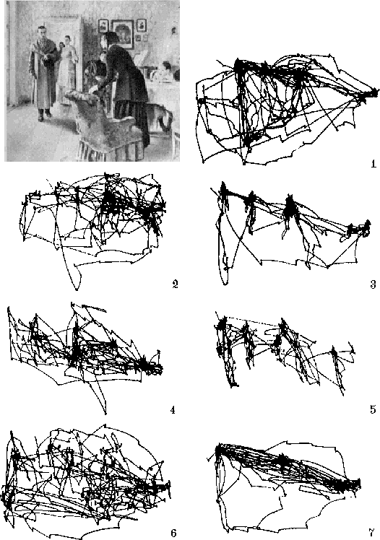
Figure 12: In sharp contrast with the simplistic biasing currently implemented in visual search models, recording eye movements while humans inspect visual scenes reveals dramatically different scanpaths depending on instructions given verbally to the observers. Our goal is to further understand and model the brain mechanisms responsible for these complex patterns of eye movements, not only for static scenes as shown here, but in the context of recognizing actions in dynamic scenes. The instructions corresponding to the scanpaths shown in this figure were (Yarbus, 1967): 1) Free examination; 2) estimate material circumstances of family; 3) give ages of the people; 4) surmise what family has been doing before arrival of “unexpected visitor;” 5) remember clothes worn by the people; 6) remember position of people and objects; 7) estimate how long the “unexpected visitor” has been away from family.

We will use an eye-tracker (Figure 12) to record the locations fixated by human observers while freely examining synthetic and natural dynamic stimuli. We have previously successfully used such equipment available in other laboratories (e.g., Egner et al, 2000) and we have developed calibration, denoising (e.g., eliminate blinks) and analysis tools. Because we currently do not have such setup available in our laboratories, we included one in the proposed equipment budget. In very promising recent experiments, Parkhurst et al. at Johns Hopkins (submitted) used a similar setup to compare predictions from our bottom-up attention model (Itti et al, 1998) to human eye movements in complex natural and artificial scenes, and found an overall very high statistical correlation between the model and human data, in particular during the first few fixations (although individual scanpaths differed substantially among humans and between humans and model, locations predicted as highly salient by the model had a high probability of being visited by humans). We consequently believe that it is reasonable to use human experiments to calibrate our new model. Extending our earlier work on visual attention, we will investigate such issues as: (i) Given a video clip, what draws the viewer's attention to a specific object or action, and then expands that attention to determine the minimal subscene containing it? (ii) Given a minimal subscene, what sentences does the viewer generate to describe it, and to what extent does the initial focus of attention bias the type of sentence structure used for the description? (iii) Given a question about a visual scene, how does this provide a top-down influence on mechanisms of attention as the viewer examines the scene in preparation to answer the question?
In addition to recording eye movements and comparing human scanpaths to the model-generated scanpaths, we will record decisions, errors, and record reaction times. The specific experiments to be carried out to address the three aforementioned issues will then consist of tracking eye movements while subjects look at a still picture or video clip with various instructions. Subjects may asked to describe a scene at varying levels of detail, or may be asked a question, and instructed to verbally state their answer as quickly as possible. A particularly interesting issue for investigation is how attending actions (“what action is the subject carrying out?”) may differ from attending to objects (e.g., “what is the actor hammering?") for the same dynamic scene presented to the subject. Their eye movements will be recorded. Reaction times will be measured from the start of stimulus presentation for each word of the verbal response (which will be recorder in digital form using a microphone connected to the sound card of the computer presenting the stimuli) to tease apart the attentional processes revealed by tracking movements which we may regard as an index for action and object recognition, and the verbal response which requires prior recognition but involves further symbol selection and sentence construction. We must design a head stabilization system (which in our experience greatly improves the quality of the recorder data) that does not prevent the subjects from speaking.

Functional Neuroimaging Experiments
The goal of the proposed functional neuroimaging experiments at Brookhaven National Laboratory is to tease apart for the various tasks which brain areas are activated in which order while observers examine video clips. The stimuli to be used will be a subset of the stimuli used for the psychophysics experiments at USC. Subject recruitment and selection procedures are described in Section E, Human Subjects.
We will use an event-related paradigm and scan at 4 Tesla to observe the temporal development of hemodynamic responses throughout the subjects’ brains. Our specific aim for the fMRI experiments is to chart what brain regions are recruited at different points in time and how this depends on the task. For example, “who is John hitting” will primarily draw the subjects’ attention to the object of John’s actions, while “look at John” will emphasize the detection and recognition of John within the scene. Differential activation between such tasks will help us identify the time course and network of brain regions involved in focusing on actions and analyzing minimal subscenes whether in scene description or question answering.
Neuroimaging experimental procedure: Subjects will be recruited for the fMRI experiments at BNL. All subjects will be asked not to drink alcohol for at least 24 hours, or consume caffeine on the day of the study. On the day of the MRI, each subject will also be required to have a urine toxicology screen (including cannabis, cocaine, amphetamine, barbiturates, benzodiazepines, PCP and opiates). Since the acute effects of many of these substances may be confounding variables in the fMRI, we will exclude subjects who are under the acute influence of illicit drugs (with positive urine screen). Because the long-term risk of MRI is still unknown in pregnancy, a urine pregnancy test is also required in female subjects prior to the MRI; pregnant women will not be studied. Subjects will of course be warned well in advance of these exclusion criteria.
All MRI studies will be performed on the 4T Varian scanner located in the High Field MR Laboratory at BNL. The scanner is equipped with the Siemens Sonata EPI hardware (maximum gradient strength per channel 40mT/m, slew rate 200 mT/(m(ms) ). The standard quadrature head resonator will be used for all studies. Stimulus presentation will use an LCD monitor (identical to the one used for psychophysics at USC), an adjustable system of binoculars and mirrors to allow viewing from inside the scanner, and a non-magnetic pushbutton system to collect responses. Instead of sounding out the answer or scene description, subjects will be asked to mentally formulate a sentence in response and to press the pushbutton as soon as this sentence is formulated (Figure 13).
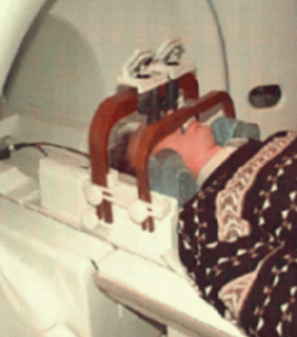

Figure 13: Apparatus for imaging while performing psychophysical discrimination experiments. In collaboration with Prof. Koch's group from the California Institute of Technology (Caltech), we have developed a unique high-quality display system for the presentation of visual stimuli. This system uses high-quality binoculars and adjustable mirrors to allow subjects to view stimuli on a shielded flat-panel display in the scanner room. A custom-molded bite-bar for each subject ensures stabilization of the head during the duration of the experiment, in addition to substantial head cushioning and padding. In addition, a non-magnetic response button system is installed in the magnet in order to monitor each subject's performance during the tasks.

All MRI studies will start with the acquisition of a sagittal T1-weighted spin-echo localizer (TE/TR 11/500, 5 mm slice thickness, 1 mm gap, 24 cm FOV, 192 phase encoding steps, 1.5 minutes scan time), followed by an axial 3D MDEFT sequence, which is ideal for the delineation of anatomical structures due to its high tissue contrast and will be used for spatial normalization of each subject's brain to a standard atlas (see next section). Functional MRI will be performed using a coronal single shot gradient-echo EPI sequence (TE/TR 20/2500, 4 mm slice thickness, 1 mm gap, 30 slices, 20 cm FOV, 64x64 resolution, 200 kHz bandwidth with ramp sampling). For most stimuli, the entire brain will be successively scanned 100 times, yielding a total scan time of 4:10 minutes (time resolution = TR = 2.5s) per scan. The first 4 images (10 seconds) of each scan will be used to obtain MR equilibrium, and will be discarded for image reconstruction. The total scan time per visit typically will be 1/2 hour, during which several repetitions of a subset of the psychophysical tasks performed at USC will be repeated, in randomized order. Given the restricted resources available for these experiments, and the significant overhead of preparation, data management, and data analysis required for each scan, we expect to scan approximately 20 subjects each project year.
Neuroimaging data analysis: A first analysis of fMRI data sets will be performed on dedicated UNIX workstations (SGI and Compaq) at BNL. Some of the analyses will be performed using a custom software written in IDL language and package (Research Systems, Boulder, CO) and AVS (Advanced Visual Systems, Inc., Waltham, MA). We will use the SPM package for motion correction. Group activation will be evaluated by transforming the individual scans into Talairach space (see below) and performing statistical comparisons with SPM. We will employ a variety of imaging techniques including those we have ourselves developed (Itti et al., 1997; 2001mrm; Ernst et al., 1999). Scans will be normalized to Talairach space; hemodynamic responses will then be computed on a voxel-by-voxel basis in SPM, will be pooled into activated "regions of interest" (ROIs), and the average responses over those ROIs will be pooled across scanning sessions.

Expected outcome and impact
We have proposed a basic scientific analysis of the relation between action and language which uses computational modeling of neural systems to integrate data on neural circuitry of the monkey brain with data on human brain and behavior gathered by ourselves using both psychophysics and fMRI. The result will be a set of detailed models of the role of interactions between multiple brain regions in scene recognition, scene description and question-answering. The proposed study benefits from extensive previous work from our groups, in functional neuroimaging, data analysis and processing, psychophysics design and data collection, detailed computational modeling, and computer vision. In addition to the specific models and experimental data we develop during the funding period, this research will make an important methodological contribution: showing how a combination of detailed quantitative modeling of neural systems based in part on data from studies of the monkey brain, human psychophysics, and fMRI can provide a useful new approach towards a greater computational understanding of the more complex aspects of human brain function. For such complex problems, rather sophisticated task designs are necessary, which often are not practical to use with animal preparations or, as in the case here of use of language, are simply not in the monkey repertoire. Nonetheless, we have shown how we will test and develop the Mirror System Hypothesis to ground our models of the human brain with a set of circuits for which strong monkey-human homologies are indeed available. We will complement studies of object-based attention by providing new insights into action-based attention, to help understand how the modulatory effect of attention differs with the nature of the task being performed, as in scene description versus question answering, where in each case we can design experiments which differentially employ a number of processes. In addition, the computational understanding of high-level brain function uses fMRI to investigate higher brain function at the level of a network of brain regions, and combining fMRI with detailed quantitative monkey-inspired modeling of circuitry within these regions (aided by our techniques for synthetic brain imaging) will allow us to interpret the fMRI results in terms of computation within neural systems. We believe that these models will help define a new framework for clinical studies on aphasia and apraxia. Thus, in addition to journal publication of our modeling and experiments, we will provide expositions of our findings in a form accessible to neurologists concerned with the overlaps and differences in the effects of brain lesions on language and action.

Literature Cited
Allen, J. F. Towards a general theory of action and time. Artificial Intellignece, 23:123-154, 1984.
Arbib, M. A., and Didday, R. L. (1975) Eye-Movements and Visual Perception: A Two-Visual System Model, Int. J. Man-Machine Studies, 7:547-569.
Arbib, M.A., and Caplan, D., 1979, Neurolinguistics must be Computational, Behavioral and Brain Sciences 2:449-483.
Arbib, M.A., and Grethe, J.S., (Eds.), 2001, Computing the Brain: A Guide to Neuroinformatics, San Diego: Academic Press Arbib, M.A., and Rizzolatti, G., 1997, Neural expectations: a possible evolutionary path from manual skills to language. Communication and Cognition, 29:393-424.
Arbib, M.A., Billard, A., Iacoboni, M., and Oztop, E., 2000, Synthetic Brain Imaging: Grasping, Mirror Neurons and Imitation, Neural Networks, 13: 975-997.
Arbib, M.A., Bischoff, A., Fagg, A. H., and Grafton, S. T., 1994, Synthetic PET: Analyzing Large-Scale Properties of Neural Networks, Human Brain Mapping, 2:225-233.
Barth, E, Zetzsche, C, Rentschler, I, Intrinsic two-dimensional features as textons, J Opt Soc Am A Opt Image Sci Vis, Vol. 15, No. 7, pp. 1723-1732, Jul 1998.
Benson, D.F., and Ardila, A., 1996, Aphasia: A Clinical Perspective, New York, Oxford: Oxford University Press.
Bobick, A. and Ivanov, Y.A. Action recognition using probabilistic parsong. In: IEEE Proceedings of Computer Vision and Pattern Recognition, Santa Barbara, CA, 1998
Bota, M., and Arbib, M.A., 2001, The NeuroHomology database, Neurocomputing, 38-40:1627-1631.
Brand, M., Oiiver, N. and Pentland, A. Coupled hidden markov models for complex action recognition. In IEEE Proceedings of Computer Vision and Pattern Recognition, pp. 568-574, Puerto Rico, 1997.
Bregler, C. Learning and recognizing human dynamics in video sequences. In IEEE Proceedings of Computer Vision and Pattern Recognition, pp. 568-574, Puerto Rico, 1997.
Bremond, F and Medioni, G. Scenario Recognition in Airborne Video Imagery. In DARPA Image Understanding Workshop, pp. 211-216, 1998.
Bremond, F and Medioni, G. Scenario Recognition in Airborne Video Imagery. In the workshop of Computer Vision and Pattern Recognition on Interpretation of Visual Motion, Santa Barbara, 1998.
Bremond, F and Thonnat, M. Analysis of human activities described by image sequences. In: Proc of the 10th international FLAIRS conference, Florida, May 1997.
Bridgeman, B. (1999) Separate representations of visual space for perception and visually guided behavior. In G. Aschersleben, T. Bachmann & J. Müsseler (Eds.), Cognitive Contributions to the Perception of spatial and Temporal Events. Amsterdam: Elsevier Science B. V. , pp. 3-13
Bridgeman, B., Peery, S., and Anand, S. (1997) Interaction of cognitive and sensorimotor maps of visual space. Perception & Psychophysics, 59:456-469.
Buccino, G., Binkofski, F., Fink, G.R., Fadiga, L., Fogassi, L., Gallese, V., et al., 2001; Action observation activates premotor and parietal areas in a somatotopic manner: an fMRI study. Eur J Neurosci 13: 400-4.
Cannon, M W, Fullenkamp, S C, Spatial interactions in apparent contrast: inhibitory effects among grating patterns of different spatial frequencies, spatial positions and orientations, Vision Res, Vol. 31, No. 11, pp. 1985-98, 1991.
Castiello, U., Paulignan, Y., and Jeannerod, M. (1991) Temporal dissociation of motor responses and subjective awareness: A study in normal subjects. Brain 114:2639-2655.
Edelman, S. and Intrator, N. (2001). A productive, systematic framework for the representation of visual structure. In Leen, T., editor, NIPS (Advances in Neural Information Processing Systems), volume 13, Cambridge, MA. MIT Press.
Egner, S., Itti, L., and Scheier, C.R. Comparing attention models with different types of behavior data, In: Investigative Ophthalmology and Visual Science (Proc. ARVO 2000), Vol. 41, No. 4, p. S39, Mar 2000.
Ernst, T., Speck, O., Itti, L. and Chang, L. Simultaneous correction for interscan patient motion and geometric distortions in echoplanar imaging, Magnetic Resonance in Medicine, Vol. 42, No. 1, pp. 201-5, Jul 1999.
Fagg, A. H., and Arbib, M. A., 1998, Modeling Parietal-Premotor Interactions in Primate Control of Grasping, Neural Networks, 11:1277-1303.
Friston, K J, Williams, S, Howard, R, Frackowiak, R S, Turner, R, Movement-related effects in fMRI time-series, Magn Reson Med, Vol. 35, No. 3, pp. 346-355, Mar 1996.Gallant et al., 1996
Gandhi SP, Heeger DJ, Boynton GM. Free in PMC , Related Articles Spatial attention affects brain activity in human primary visual cortex. Proc Natl Acad Sci U S A. 1999 Mar 16;96(6):3314-9.
Goddard, N.H. Incremental model-based discriminationof articulated movement from motion features. In Proc IEEE workshop on motion of non-rigid and articulated objects, pp. 89-95, Austin, TX, 1994.
Goodale, M.A., A. D. Milner, L. S. Jakobson & D. P. Carey, 1991. A neurological dissociation between perceiving objects and grasping them. Nature, 349:154-156.
Grafton, S.T., M. A. Arbib, L. Fadiga, & G. Rizzolatti, 1996b. Localization of grasp representations in humans by PET: 2. Observation compared with imagination. Experimental Brain Research, 112:103-111.
Herkovits, A. Spatial and temporal reasoning, Chapter 6, pp. 155-202, Kluwer Academic Publishers, 1997.
Itti, L. and Koch, C. Computational Modeling of Visual Attention, Nature Reviews Neuroscience, Vol. 2, No. 3, pp. 194-203, Mar 2001.
Itti, L. and Koch, C. Feature Combination Strategies for Saliency-Based Visual Attention Systems, Journal of Electronic Imaging, Vol. 10, No. 1, pp. 161-169, Jan 2001.
Itti, L., and Koch, C. A saliency-based search mechanism for overt and covert shifts of visual attention, Vision Research, Vol. 40, No. 10-12, pp. 1489-1506, May 2000.
Itti, L., Braun J. and Koch C. Modeling the Modulatory Effect of Attention on Human Spatial Vision. In: Proceedings NIPS 2002, in press.
Itti, L., Chang, L. and Ernst, T. Automatic scan prescription for brain MRI, Magnetic Resonance in Medicine, Vol. 45, No. 3, pp. 486-494, Mar 2001.
Itti, L., Chang, L., Mangin, J. F., Darcourt, J., and Ernst, T. Robust multimodality registration for brain mapping, Human Brain Mapping, Vol. 5, No. 1, pp. 3-17, 1997.
Itti, L., Koch, C., and Braun, J. Revisiting Spatial Vision: Towards a Unifying Model, Journal of the Optical Society of America, JOSA-A, Vol. 17, No. 11, pp. 1899-1917, Nov 2000.
Itti, L., Koch, C., and Niebur, E. A Model of Saliency-Based Visual Attention for Rapid Scene Analysis, IEEE Transactions on Pattern Analysis and Machine Intelligence, Vol. 20, No. 11, pp. 1254-1259, Nov 1998.
Kanwisher N. Related Articles Faces and places: of central (and peripheral) interest. Nat Neurosci. 2001 May;4(5):455-6.
Kimura, D., 1993, Neuromotor Mechanisms in Human Communication (Oxford Psychology Series No. 20). Oxford University Press/Clarendon Press, Oxford, New York.
Koch, C, Ullman, S, Shifts in selective visual attention: towards the underlying neural circuitry, Hum Neurobiol, Vol. 4, No. 4, pp. 219-27, 1985.
Kollnig, H. Nagel, H. and Otte, M. Association of motion verbswith vehicle movements extracted from dense optical flow fields. In Proceedings of the European Conference on Computer Vision, May 1994.
Lee, D. K., Itti, L., Koch, C. and Braun, J. Attention activates winner-take-all competition among visual filters, Nature Neuroscience, Vol. 2, No. 4, pp. 375-81, Apr 1999.
Menon V, White CD, Eliez S, Glover GH, Reiss AL. Related Articles Analysis of a distributed neural system involved in spatial information, novelty, and memory processing. Hum Brain Mapp. 2000 Oct;11(2):117-29.
Miau, F. and Itti, L. A Neural Model Combining Attentional Orienting to Object Recognition: Preliminary Explorations on the Interplay Between Where and What, In: Proc. IEEE Engineering in Medicine and Biology Society (EMBS), in press.
Miau, F., Papageorgiou, C., and Itti, L. Neuromorphic algorithms for computer vision and attention, In: Proc. SPIE 46 Annual International Symposium on Optical Science and Technology, in press.
Morris, R. and Hogg, D. Statistical models of object interaction. In proc of the international conference on computer vision (ICCV), Bombay, 1998
Noton, D. & Stark, L., 1971, Scanpaths in Eye Movements during Pattern Perception, Science (Washington), 171, 308.
Olshausen, B A, Field, D J, Emergence of simple-cell receptive field properties by learning a sparse code for natural images, Nature, Vol. 381, pp. 607-609, 1996.
Oztop, E., and Arbib, M.A., 2001, Schema Design and Implementation of the Grasp-Related Mirror Neuron System, submitted for publication.
Papageorgiou, C, Evgeniou, T, Poggio, T, A Trainable Pedestrian Detection System, In: Intelligent Vehicles, pp. 241-246, Oct 1998.
Pashler, H E, The Psychology of Attention, In: The Psychology of Attention, Cambridge, MA:MIT Press, 1998.
Pearl, J. Probabilistic reasoning in intelligent systems: networks of feasible inference. Morgan Kaufman, San Mateo, CA, 1988.
Reinagel, P, Zador, A M, Natural scene statistics at the centre of gaze, Network: Comput Neural Syst, Vol. 10, pp. 341-350, 1999.
Rensink RA. Seeing, sensing, and scrutinizing. Vision Res. 2000;40(10-12):1469-87.
Riesenhuber, M, Poggio, T, Hierarchical models of object recognition in cortex, Nat Neurosci, Vol. 2, No. 11, pp. 1019-1025, Nov 1999.
Rizzolatti G, Fogassi L, Gallese V. Neurophysiological mechanisms underlying the understanding and imitation of action. Nat Rev Neurosci. 2001 Sep;2(9):661-70.
Rizzolatti, G, and Arbib, M.A., 1998, Language Within Our Grasp, Trends in Neurosciences, 21(5):188-194.
Rizzolatti, G., Camarda, R., L. Fogassi, M. Gentilucci, G. Luppino, & M. Matelli, l988. Functional organization of inferior area 6 in the macaque monkey II. Area F5 and the control of distal movements. Experimental Brain Research, 71:491-507.
Rizzolatti, G., Fadiga L., Gallese, V., and Fogassi, L., 1996, Premotor cortex and the recognition of motor actions. Cogn Brain Res., 3: 131-141.
Rizzolatti, G., Fadiga, L., Matelli, M., Bettinardi, V., Perani, D., and Fazio, F., 1996a, Localization of grasp representations in humans by positron emission tomography: 1. Observation versus execution. Exp Brain Res., 111:246-252.
Rybak, I A, Gusakova, V I, Golovan, A V, Podladchikova, L N, Shevtsova, N A, A model of attention-guided visual perception and recognition, Vision Res, Vol. 38, No. 15-16, pp. 2387-2400, Aug 1998.
Sablayrolles, P. Semantique formelle de l’expression du mouvement. De la semantique lexicale au calcul de la structure du discours en Francais. Ph.D. Thesis, These IRIT, Universite Paul Sabatier, Toulouse, 1995.
Schirra, J. Connecting Visual and Verbal Space. In Proc of the 4th workshop on time, space, movement and spatio-temporal reasoning, Bonas, France, Sept 1992.
Schill, K, Umkehrer, E, Beinlich, S, Krieger, G, Zetzsche, C, Scene analysis with saccadic eye movements: top-down and bottom-up modeling, Journal of Electronic Imaging, in press.
Sillito, A M, Grieve, K L, Jones, H E, Cudeiro, J, Davis, J, Visual cortical mechanisms detecting focal orientation discontinuities, Nature, Vol. 378, No. 6556, pp. 492-6, Nov 1995.
Stark, L W, Choi, Y S, Experimental Methaphysics: The Scanpath as an Epistemological Mechanism, In: Visual Attention and Cognition, (Zangemeister, W H, Stiehl, H S, Freska, C Ed.), pp. 3-69, Elsevier Science B.V., 1996.
Stark, L W, Privitera, C M, Yang, H, Azzariti, M, Ho, Y F, Blackmon, T, Chernyak, D, Representation of human vision in the brain: how does human perception recognize images? Journal of Electronic Imaging, Vol. 10, No. 1, 2001.
Stokoe W. C., 2001, Language in Hand: Why Sign Came Before Speech, Washington, DC: Gallaudet University Press.
Tagamets, M. A. & Horwitz, B., 1998, Integrating electrophysiological and anatomical experimental data to create a large-scale model that simulates a delayed match-to-sample human brain imaging study. Cerebral Cortex, 8, 310- 320.
Tagamets, M. A. & Horwitz, B., 2000, A model of working memory: Bridging the gap between electrophysiology and human brain imaging. Neural Networks, 13, 941- 952.
Taira, M., S. Mine, A. P. Georgopoulos, A. Murata, & H. Sakata, 1990. Parietal cortex neurons of the monkey related to the visual guidance of hand movement. Experimental Brain Research, 83:29-36.
Tootell, R B, Reppas, J B, Kwong, K K, Malach, R, Born, R T, Brady, T J, Rosen, B R, Belliveau, J W, Functional analysis of human MT and related visual cortical areas using magnetic resonance imaging, J Neurosci, Vol. 15, No. 4, pp. 3215-30, Apr 1995.
Treue, S, Martinez Trujillo, J C, Feature-based attention influences motion processing gain in macaque visual cortex, Nature, Vol. 399, No. 6736, pp. 575-579, Jun 1999.
Tsotsos, J K, Culhane, S M, Wai, W Y K, Lai, Y H, Davis, N, Nuflo, F, Modeling Visual-Attention via Selective Tuning, Artificial Intelligence, Vol. 78, No. 1-2, pp. 507-45, 1995.
Ungerleider, L.G., and Mishkin, M., 1982, Two cortical visual systems, in Analysis of Visual Behavior, (D.J. Ingle, M.A. Goodale and R.J.W. Mansfield, Eds.), MIT Press.
VanRullen, R. and Thorpe, S. J. The time course of visual processing: from early perception to decision-making. Journal of Cognitive Neuroscience, 13(4), 454-461, 2001
Wolfe, J M, Guided search 2.0: a revised model of visual search, Psychonomic Bull Rev, Vol. 1, pp. 202-238, 1994.
Yarbus, A, Eye Movements and Vision, New York:Plenum Press, 1967.
Zetzsche, C, Schill, K, Deubel, H, Krieger, G, Umkehrer, E, Beinlich, S, Investigation of a sensorimotor system for saccadic scene analysis: an integrated approach, In: From animals to animats, Proc. of the Fifth Int. Conf. on Simulation of Adaptive Behavior, Vol. 5, pp. 120-126, 1998.

